PROJECT PROGRESS REPORT
(Progress Report no. 3)
1. Student Information
Student Name | PATEL MAN VISHNUBHAI.
Enrollment Number | 25IC03CA053
Program/Branch | Master Of Computer Applications
Semester | 3
Contact Number | 8849948963
Email ID | 25ic03ca053@ppsu.ac.in

2. Project Details
Type | Research Project
Department/Domain | MCA CA(DS/ML) / AI & ML
Mentor Name | Srikant Singh
Start Date | 08-06-2026
End Date | 03-10-2026

3. Work Progress Summary
- Project Title:
- OpenCV - Based System for Crack Identification and Width Estimation

- System architecture:
- The proposed system follows a modular architecture for automated crack detection and width estimation.
- The workflow begins with image acquisition using a camera or drone. The captured image is passed to the preprocessing module, where resizing, grayscale conversion, and noise reduction are performed.
- The enhanced image is then processed using OpenCV algorithms for crack detection through edge detection and contour extraction.
- The detected crack is analyzed by the width estimation module, which calculates crack dimensions using pixel measurements and calibration techniques.
- Finally, the crack is classified according to its severity, and the results are displayed and stored for future analysis.
Architecture Flow:
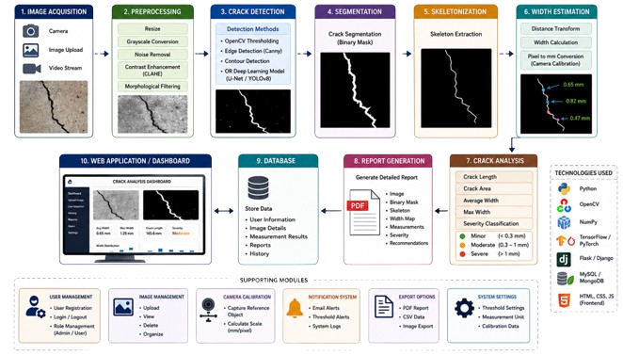

- Database design:
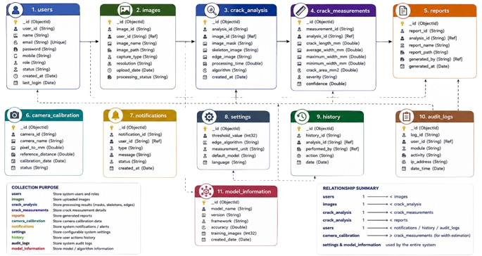
- Module Planning:
Module 1: Image Acquisition
Purpose: Acquire crack images from different sources.
Functions:
- Capture images using a camera.
- Upload images from the local system.
- Validate image format (JPG, PNG, BMP).
- Store image metadata.

Input: Crack image/video

Module 2: Image Preprocessing
Purpose: Improve image quality for accurate crack detection.
Functions:
- Resize image.
- Convert RGB to grayscale.
- Apply Gaussian Blur for noise removal.
- Enhance contrast using CLAHE.
- Perform normalization.
Input: Original image

Module 3: Crack Detection
Purpose: Detect crack regions from the preprocessed image.
Functions:
- Apply thresholding.
- Detect edges using Canny Edge Detection.
- Extract contours.
- Identify crack pixels.
Input: Enhanced image

Module 4: Crack Segmentation
Purpose: Separate the crack from the background.
Functions:
- Generate binary mask.
- Remove unwanted objects.
- Refine crack boundaries.
Input: Detected crack

Module 5: Skeletonization
Purpose: Reduce the crack to a one-pixel-wide centerline.
Functions:
- Extract crack skeleton.
- Preserve crack topology.
- Prepare for width estimation.
Input: Binary mask

Module 6: Crack Width Estimation
Purpose: Calculate crack width accurately.
Functions:
- Apply Distance Transform.
- Measure crack width at every skeleton point.
- Convert pixels to millimeters using calibration.
- Compute minimum, maximum, and average width.
Input: Skeleton image

Module 7: Crack Analysis
Purpose: Analyze crack characteristics.
Functions:
- Calculate crack length.
- Calculate crack area.
- Calculate average and maximum width.
- Generate statistical measurements.
Input: Width measurements

Module 8: Severity Classification
Purpose: Classify crack severity.
Functions:
- Minor (< 0.30 mm)
- Moderate (0.30–1.00 mm)
- Severe (> 1.00 mm)
Input: Crack width

Module 9: Report Generation
Purpose: Generate inspection reports.
Functions:
- Create PDF reports.
- Export CSV/Excel reports.
- Save processed images.
- Store measurement results.
Input: Analysis results

Module 10: Dashboard / Web Application
Purpose: Provide a user-friendly interface.
Functions:
- User login.
- Upload crack images.
- View analysis results.
- Download reports.
- Search history.
- Manage users and settings.
Input: User request
4. Tasks Accomplished
- Conducted a comprehensive literature review on crack detection and width estimation techniques using OpenCV and Deep Learning.
- Finalized the project objectives, scope, and system requirements.
- Designed the overall system architecture, including image acquisition, preprocessing, crack detection, segmentation, skeletonization, width estimation, crack analysis, report generation, database, and dashboard modules.
- Selected the technology stack, including Python, OpenCV, TensorFlow/ PyTorch (optional), Flask/Django, MongoDB, NumPy, and Matplotlib.
- Designed the MongoDB database schema for storing user information, crack images, analysis results, reports, camera calibration data, and system logs.
- Planned and documented all software modules with their inputs, outputs, and functionalities.
- Set up the complete development environment by installing Python, OpenCV, MongoDB, Visual Studio Code, and the required libraries.
- Collected and organized crack image datasets for system development and testing.
- Developed the initial image preprocessing module, including image resizing, grayscale conversion, Gaussian filtering, contrast enhancement (CLAHE), and thresholding.
- Implemented the crack detection pipeline using OpenCV techniques such as edge detection, contour extraction, and binary segmentation.
- Designed the crack width estimation methodology using skeletonization and distance transform for accurate measurement.
5. Tasks in Progress / Next Plan
- initial module implementation
- coding approach

6. Learnings / Skills Acquired
- Gained a strong understanding of Computer Vision and Digital Image Processing concepts for crack identification and measurement.
- Learned to use the OpenCV library for image preprocessing, edge detection, contour extraction, segmentation, and feature extraction.
- Improved Python programming skills by implementing image processing algorithms and developing modular application components.
- Acquired practical knowledge of image enhancement techniques such as grayscale conversion, Gaussian filtering, histogram equalization (CLAHE), thresholding, and morphological operations.
- Learned the implementation of Skeletonization and Distance Transform algorithms for accurate crack width estimation.
- Developed an understanding of camera calibration and pixel-to-millimeter conversion for real-world crack measurement.
- Gained experience in MongoDB database design, including creating collections for users, images, crack analysis, measurements, reports, and system history.
- Learned to design a modular software architecture, workflow diagrams, and database schema for a scalable computer vision application.
- Enhanced knowledge of Flask/Django-based web application development for integrating image processing with a dashboard interface.
- Learned to generate structured outputs such as inspection reports, statistical summaries, and visualization dashboards from processed crack data.
- Strengthened problem-solving, debugging, analytical thinking, and software development practices while implementing and testing different project modules.

References:
- Sandbhor, S., Desai, P., Ranjan, A., Sharma, D., Baig, S., Agarwal, K., & Wadhwa, R. S. (2024, June). Computer Vision and Sensor-Based Concrete Crack Detection System. In International Conference on Data Analytics & Management (pp. 319-336). Singapore: Springer Nature Singapore.
- Giulietti, N., Revel, G. M., & Chiariotti, P. (2025). Automated vision-based concrete crack measurement system. Measurement, 242, 115858.
- Kim, H., Lee, S., Ahn, E., Shin, M., & Sim, S. H. (2021). Crack identification method for concrete structures considering angle of view using RGB-D camera-based sensor fusion. Structural Health Monitoring, 20(2), 500-512.
- Jin, S., Lee, S. E., & Hong, J. W. (2020). A vision-based approach for autonomous crack width measurement with flexible kernel. Automation in Construction, 110, 103019.p
Evaluation (To be filled by Mentor)
Criteria | Bloom’s Level | Excellent (20) | Good (15) | Average (10) | Poor (5) | Marks Obtained (Out of 20)
Problem Definition | L4–Analyze | Clearly defined, justified real-world problem | Defined but lacks depth | Vague problem | No clear problem
Project Title Relevance | L2–Understand | Highly precise and aligned | Mostly relevant | Partially relevant | Misleading
Scope of Work | L5–Evaluate | Well-defined scope, deliverables, constraints | Defined with minor gaps | Broad/unclear | No scope
Related Study | L4–Analyze | 3–5 sources analyzed critically | Sources listed | Minimal references | No study
Clarity & Presentation | L3–Apply | Structured, professional | Minor issues | Some confusion | Poor
Total Marks
Evaluation
Student Signature | Mentor (Company)  Signature

Mentor (Institute) Remarks
________________________________________________________________________________________________________________________________________________________________________________________________________________________________________________________________________________________________________________________________________________________________________________________________________________________________________________________________________________________________________________________________________________________________________________________________________________________________________________________________________________________________________________________________________________________________________________________________________________________________________________________________________________________________________________________________________________________________________________________________________________________________________________________________________________________________________________________________________________________________________________________________________________________________________________________________________________________________________________________________________________________________________

